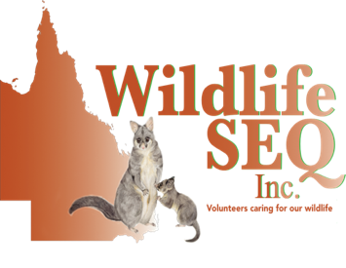

Membership Application

|  |  |  |
| --- | --- | --- |
| **Membership Details:** | | |
| Membership Required: | New | Renewal |
| Membership Type: | Single $34.50 | Family $49.50 |
| Memberships are non refundable. Family memberships can consist of up to 2 adults, 2 children living at the same address | | |

|  |  |  |  |
| --- | --- | --- | --- |
| **Primary Member Details:** | | **Second Member Details (Family Only)** | |
| First Name: |  | First Name: |  |
| Surname: |  | Surname: |  |
| Date of Birth: |  | Date of Birth: |  |
| Mobile No: |  | Mobile No: |  |
| Email: |  | Email: |  |
| **Children Details:** | |  | |
| Child 1: |  | Date of Birth: |  |
| Child 2: |  | Date of Birth: |  |

|  |  |  |  |
| --- | --- | --- | --- |
| **Residential Address:** | | **Postal Address: (if applicable)** | |
| Street Number: |  | Street or PO: |  |
| Street Name: |  | Street Name: |  |
| Suburb: |  | Suburb: |  |
| Postcode: |  | Postcode: |  |

|  |  |  |  |
| --- | --- | --- | --- |
| **Emergency Contact Details:**  **(Primary Member)** | | **Emergency Contact Details:**  **(Second Member)** | |
| First Name: |  | First Name: |  |
| Surname: |  | Surname: |  |
| Relationship: |  | Relationship: |  |
| Mobile No: |  | Mobile No: |  |

|  |  |  |
| --- | --- | --- |
| Office Use Only | | |
| Membership # | Receipt # | Approved By: |

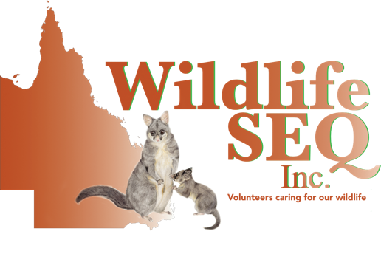

Membership Application and Renewal Form

|  |  |  |  |  |
| --- | --- | --- | --- | --- |
| **Are you a current member or been a member of another Wildlife Organisation?** | | | | |
| Organisation: |  | Are you still a current member? | Yes | No |
| Organisation: |  | Are you still a current member? | Yes | No |
| Have you ever been denied a Wildlife Rehabilitation Permit or had one cancelled or revoked by either a wildlife organisation or the DES (Department of Science) | | | Yes | No |

|  |  |  |  |  |  |  |
| --- | --- | --- | --- | --- | --- | --- |
| **General Information** | | | | | | |
| Membership Type: | Carer | Animal Transport | Financial | | Land for Wildlife | |
| Have you had any previous experience with wildlife? | | | | Yes | | No |
| If yes, please provide details: | | | | | | |

|  |  |  |  |  |
| --- | --- | --- | --- | --- |
| **What type of native animal are you interested in caring for?**  **Please tick all that apply** | | | | |
| Birds | Possums | Small Mammals | Macropods | Reptiles |

|  |
| --- |
| **Do you have space for cages/aviaries? Please advise what size you can accommodate or have** |
|  |

|  |  |  |  |  |  |  |
| --- | --- | --- | --- | --- | --- | --- |
| **Can you assist with other duties? Please tick all that apply** | | | | | | |
| Fundraising | Office Duties | | Events | | Sewing | Grants |
| Construction/Building | | Social Media | | Other Please specify | | |



Membership Application and Renewal Form

|  |  |  |  |  |  |
| --- | --- | --- | --- | --- | --- |
| **Payment Details:** | | | | | |
| Bank Transfer | | Credit Card | | | PayPal |
| For PayPal payments, please use our email [info@wildlifeseq.com.au](mailto:info@wildlifeseq.com.au) using your name as your reference. PayPal payments accept credit cards or bank transfer payments. | | | | | |
| For Credit Card payments, please enter your credit card details below: | | | | | |
| Card Number: | /      /      / | |  | | |
| Expiry Date: | / | | CVV (3 digits on back) | | |
| Visa: | | | Mastercard: | | |
| By ticking this box you are confirming that you are the card holder or have the card holders permission: | | | | | |
| EFT Transfers – for bank transfer payments  **Please use your full name as the reference** | | | | Westpac  Account Name: Wildlife SEQ Inc.  BSB Number: 034 243  Account Number: 365 050 | |

By becoming a member of Wildlife SEQ Inc. you agree to:

1. Abide to all content included in all workshop manuals when carrying out any tasks on behalf of Wildlife SEQ Inc.
2. Abide by the organisations core values, policies and procedures
3. Agree to follow and adhere to Wildlife SEQ Inc. Safety Practices
4. Abide by the rules set out in the following legislation (policy will be emailed)

* Code of Practice – Care of Sick, Injured or Orphaned Protected Animals in Queensland

As part of our application process Wildlife SEQ collects personal information and matter including name, address, phone number, email address, training and experience. This information may be released to other relevant wildlife organisations including but not limited to Australia Zoo Wildlife Hospital, Department of Science (DES), RSPCA if required.

Wildlife SEQ Inc. accepts no liability for any personal injury, death, property damage/loss or financial cost arising from any voluntary work undertaken on behalf of the organisation. Wildlife SEQ Inc. holds Public Liability Insurance in the amount of $20,000,000.

|  |  |  |  |
| --- | --- | --- | --- |
| **Primary Member Signature:** | | **Second Member Signature:** | |
| Signature: |  | Signature: |  |
| Date: |  | Date: |  |

Wildlife SEQ Inc.

Wildlife Emergencies: 0468 484 994

Email: [memberships@wildlifeseq.com.au](mailto:memberships@wildlifeseq.com.au) www.wildlifeseq.com.au